**First class and higher JS functions**

JS functions divided into 2 classes:

1. First class functions.
2. Higher order functions.

**First class function:**

Functions in JS can be treated as a value; that means function can be **assigned** in a variables, **return** it in another function….etc.

**Example 1:**

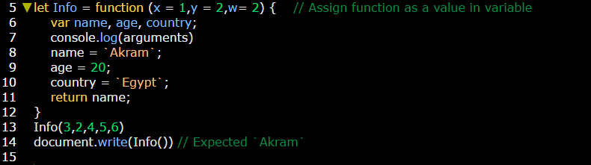

**Example 2:**

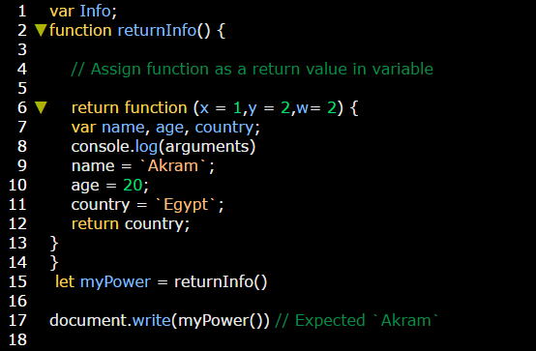

**Higher order function:**

Functions in JS can be stored another function as a parameter or return function:

**Example:** in the same previous example **returnInfo** function which stored another function inside it by return statement is considered a **high order function**.